Day Meadows Chapel Broadcast Technical Support Document.

Nov 8, 2020

Contact information:

Troy Mace: 801-400-3186 troy_mace@yahoo.com Stake Tech. Spec.

Randy Graham: 801-830-9503 thergraham@gmail.com Bldg. Tech. Spec. 14th Ward

Spencer Mecham: 801-854-8377 skmecham@gmail.com Strasburg Ward Tech. Spec.

Ryan Macdonald: 801-310-8302 ryanmac1090@gmail.com 6th Ward Tech. Spec.

Preliminary Step: Download Mevo App (Skip if installed)
- Using your phone or tablet, go to the Apple App Store or Google Play Store and download and install the free Mevo app.

Step 1 - Equipment Setup
- Set up the Camera Stand directly in front of the first pew centered directly in front of the Pulpit.
- Attach the camera to the top of the stand and aim in the direction of the pulpit.
- Attach the Ethernet adapter cable to the camera. (USB type “C” on both ends)
- Attach the CAT5 Ethernet cable from to a Switch Port inside the pulpit to the camera Ethernet adapter.
- Connect the power plug and cable to the Ethernet adapter.
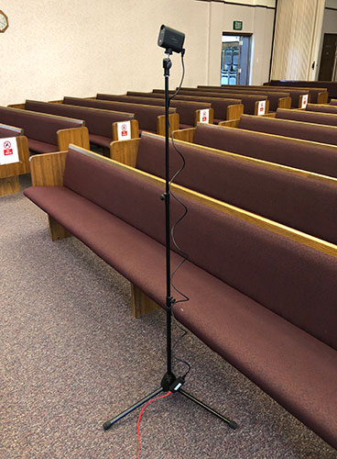

Step 2 - Connect to the Internet
Connect your Cell Phone network to the Pulpit Wifi-Fi (techmgr2 / str8narrow because the in-house (Liahona) wireless is disabled during church sacrament meeting hours.
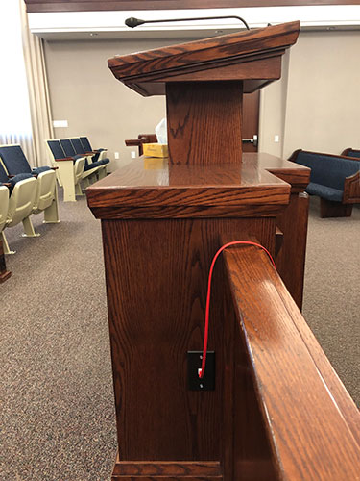
Step 4 - Connect Mevo App to Camera

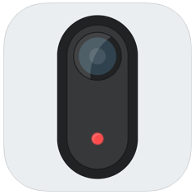

- Turn On the Mevo camera by pressing and holding the top button on the back of the camera for 3 seconds.
- Open up the Mevo app on your mobile device. It will automatically begin looking for the camera on your techmgr2 network.
- When the app opens ensure the "Ethernet" connection is stated at the bottom.
- Click the blue "Connect" button.
- If your connection is successful you should see live video from the Mevo camera.
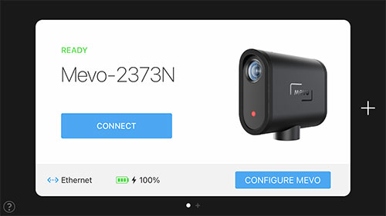
Step 5 - Recommended Camera Settings
The following settings have been tested and shown to deliver the best broadcast experience.
- Tap the red record button on the bottom right of the Mevo app.
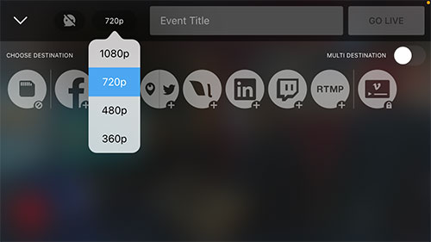
- At the top of the app you will see a default quality setting of 1080p. Tap that and select 720p. This will ensure HD quality at a lower bitrate. Encoding at the higher bitrate (1080p) is not recommended.
- In the audio settings, be sure to turn the "Auto Gain Control" off.
- Audio Mixer settings: Set Output about 3/4th or higher to the right and set Mevo so as to have very little red audio level.
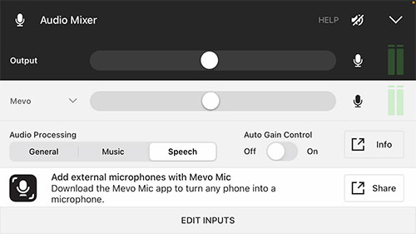
Step 6 - Set RTMP Settings
This step must be performed each Sunday by the Ward Technical Specialist.
Tap the red record button, bottom left of display. Then tap the RTMP icon.
- Tap the "Configure" button at the bottom of the app.
- Troy will text you the information needed for your Ward’s broadcast.
- Using the ward streaming info from Troy or from https://www.highlandcentralutahstake.org/tech.html, copy and paste the RTMP Url and Stream Key into the Mevo App.
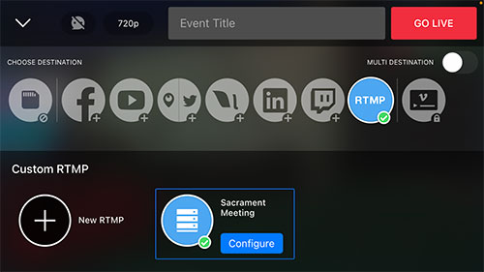
- Tap the "Save" button at the top right corner of the app.

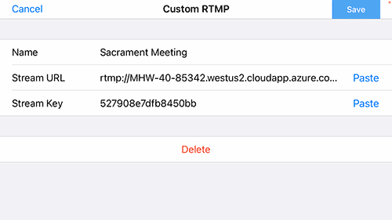
Setup RTMP settings

Step 7 - Start/Run Broadcast
- To start streaming your meeting, tap the red "GO LIVE" button at the top right of the app.
Step 8 - Viewing a Broadcast
- Send the following url to your ward members:

Viewing URL:
http://mywebcast.churchofjesuschrist.org/highlandutahcentralstake

- The viewer will see a list of broadcasts for our stake. They simply click the blue "View" button for their building to begin watching.
- If members jump on the stream before the start of the streaming meeting, a Church video (bible video) or Tabernacle Choir will start playing while they are waiting.

Step 9 - End Broadcast – Prior to Sacrament Service
- Slide the red button at the bottom of the app to the right and click "OK".
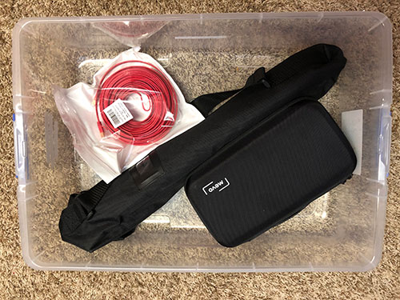
- Turn off the camera by pushing and holding the button on the back of it for 2 seconds.
- If you are the last ward in your meetinghouse, disconnect all the cables carefully and return the camera, Ethernet adaptor, Ethernet cable and stand to the lower right drawer in the Library/Media Center
Helpful URLs:
http://webcast.churchofjesuschrist.org/
http://mywebcast.churchofjesuschrist.org/highlandutahcentralstake
http://highlandcentralutahstake.org

Contact information:

Troy Mace: 801-400-3186 troy_mace@yahoo.com Stake Tech. Spec.

Randy Graham: 801-830-9503 thergraham@gmail.com Bldg. Tech. Spec. 14th Ward

Spencer Mecham: 801-854-8377 skmecham@gmail.com Strasburg Ward Tech. Spec.

Ryan Macdonald: 801-310-8302 ryanmac1090@gmail.com 6th Ward Tech. Spec.

